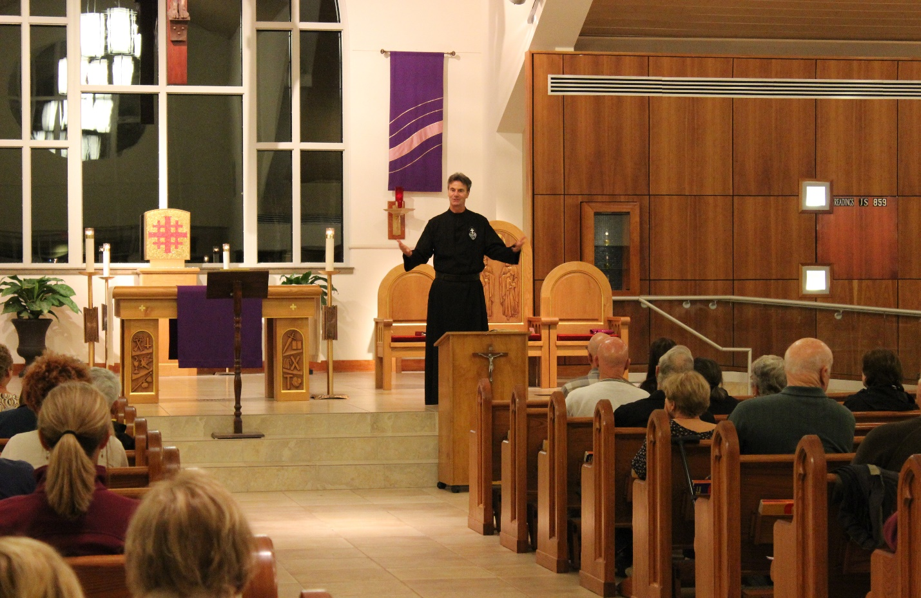
A Church without Walls:
The Ministry of Fr. Cedric Pisegna, C.P.
Fr. Cedric Pisegna, C.P., is a Passionist priest. He professed his vows to the Passionist Community in 1985, was ordained in 1991, and resides at Holy Name Community in Houston, Texas.
For the last 33 years, Fr. Cedric has traveled across the United States and Canada, preaching parish missions, sometimes called retreats. St. Paul of the Cross specialized in preaching these events as he desired all people to hear the Gospel clearly and be saved.
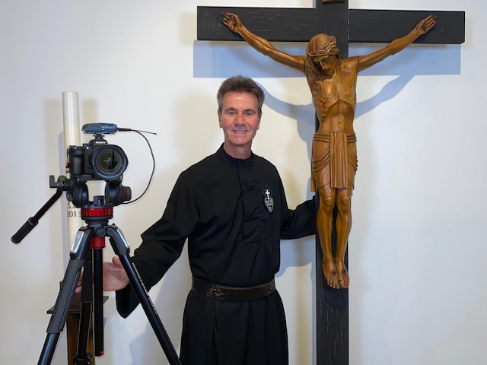
Fr. Cedric is overjoyed to carry on this unique ministry. He has preached over 500 missions in nearly every U.S. state and some Canadian provinces. Fr. Cedric’s missions endeavor to help people come to know Jesus personally while revealing the everlasting riches of the Holy Spirit. He offers the Sacrament of Reconciliation as part of every mission, using stories, personal experiences and humor to engage and draw attendees closer to God.
The Call:
A few years into his itinerant ministry, Fr. Cedric received a dream from God. God was calling him beyond and outside the walls of a brick-and-mortar church to reach those who had fallen away, those who had not yet come to faith, and those of other denominations. Fr. Cedric instinctively knew he could accomplish this dream through broadcast media.
However, having the dream and bringing it to reality demanded money, creativity, work and contacts. With courage, Fr. Cedric knocked on the doors of the major broadcast networks and various television stations nationwide. By God’s favor, over time, his ministry was embraced by all three major Christian networks, the Catholic Eternal Word Television Network (EWTN), the Protestant Trinity Broadcasting Network (TBN) and the Daystar Network. He is the only priest and Catholic on these Protestant networks and the first minister to ever be on all three simultaneously!
Because broadcast media is costly, Fr. Cedric has been permitted to use the royalties from his resources and donations from viewers to fund the production of the broadcasts as well as purchase airtime. His television program, “Live with Passion!”, can be viewed Eastern Time on the following:
- Sundays at 6:30 a.m. on EWTN
- Sundays at 7:00 a.m. on TBN
- Sundays at 7:30 am on FE-TV
- Sundays at 1:00 p.m. on the Daystar Network
- Sundays at 5:30 pm on TBN inspire
In addition, “Live with Passion!” airs on several Catholic affiliates in New York, Boston, Louisville and Long Island. You can also tune in on several radio stations.
Fr. Cedric’s programming is growing in popularity and recently earned a top 30 rating among TV ministers. Each week more and more people are discovering how to “Live with Passion!” and find new life in Christ.
Fr. Cedric says:
“I always wear the Passionist habit on television. My vow of poverty helps those on the peripheries to relate to me. I also separate myself from the other TV ministers who gain money to use on themselves. As a Passionist, I explore the meaning of suffering and help people find meaning. I reach out to those without faith, youth and the incarcerated through weekly programs and a pen pal ministry. My goal is to inspire believers, but mostly to reach those who struggle with or have not yet come to faith in Jesus.”
It all began with a dream, God’s dream, and now “Live with Passion!” has become a reality. Broadcasting since 2006, the motto of Fr. Cedric’s media ministry has been Touching Lives/Saving Souls.
To learn more about Fr. Cedric, his ministries or how to purchase his books, DVDs and CDs visit www.frcedric.org.
Quotes from friends and benefactors
of the ministries of Fr. Cedric Pisegna, C.P.

Fr. Cedric and his preaching have positively impacted my life. His wonderful preaching has helped me improve my prayer life, strengthened my relationship with the Lord, helps me to stay faithful to God and has helped me to understand the Catholic faith. In fact, his preaching has given my sister and I the encouragement to join the Rite of Christian Initiation (RCIA) classes and, God willing, we will be welcomed into the Catholic Church this year. We are thrilled about this change. Fr. Cedric explains everything in depth, which makes me watch his programs over and over again. I love his preaching! –-Esther, Maryland

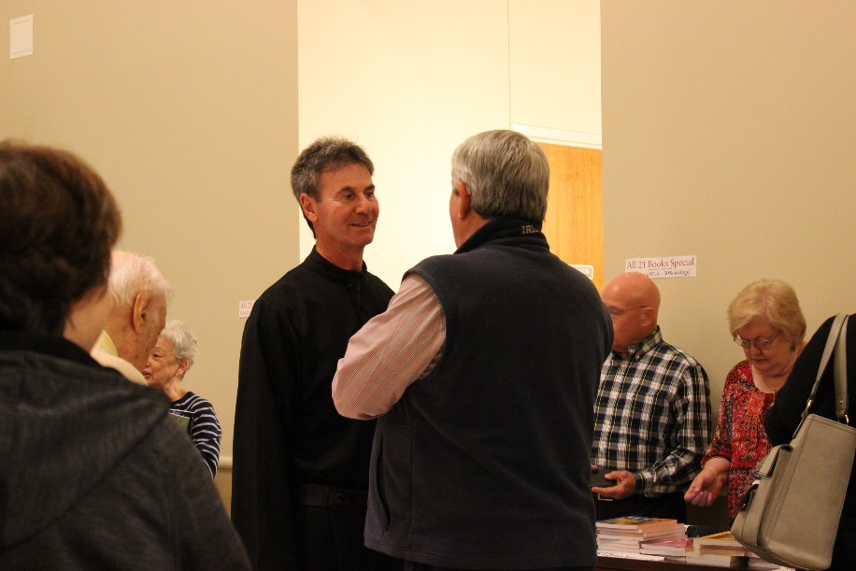
Several words come to mind when describing the mission work and ministry of Fr. Cedric: deeply spiritual, uniquely personal, very practical and humorous. Deeply spiritual because of his depth of knowledge regarding scripture and our faith and his ability to reach out to those of other faiths, or of no faith. Uniquely personal because he shares his own story, including his successes and failures, while reaching each of us in our own areas of struggle and brokenness. Very practical because his suggested solutions are not "pie in the sky" ideals but rather solutions we are all capable of
Fr. Cedric, C.P. at least trying. And humorous, which speaks for itself - his jokes are funny! Mix that with kindness and compassion and you have Fr. Cedric, a perfect example of a priest deeply touched by God, living and sharing his life with passion! I am forever changed as he is an amazing priest with an amazing message! –-Lori, Hamilton, New Jersey

I must confess that I am not of the Catholic faith, but several years ago I paused my television remote to the Live With Passion! program on TBN. I watched two of Fr. Cedric’s programs, and he totally captured me with his sermons and preaching. I realized soon after, that he had a special calling of God for his life. He possesses a vast knowledge of the Bible, is well-educated and always seems to be speaking directly to me. A great spokesman for the Catholic Church, he has written many books that I have read, and from which I have learned a lot about him personally. He is a true man of God, and I support him with my prayers always! –-Stanley, Mulberry, Florida

Fr. Cedric filled my life with the overwhelming light and love of God through one of his parish missions over 20 years ago. Through his tender words of hope in the Pascal Mystery, and his gentle, encouraging character, Fr. Cedric has walked me through the most difficult trials and sufferings of my life. Whether it was through one of his missions that I attended, a book he wrote, one of his television programs or simply through an email, he has always had the exact right thing to say that I needed to hear. I have witnessed this phenomenon happen in others as I have helped with many of his missions and lead several book studies using his books. I have seen faces light up with sheer joy at his missions! People feel he writes or speaks to them personally. This, I believe is Fr. Cedric’s special God-given gift that he uses so graciously well to touch the world with the heart of Jesus. —Mary, Saginaw, Michigan

