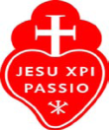
Fr. Cedric’s Prison Pen-Pal Ministry
PO Box 542
Walker, Louisiana 70805-0542
frcedric@frcedric.org
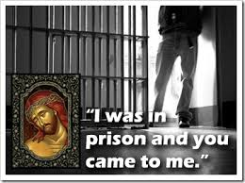
nyfirmin@gmail.com
Join Our Pen Pal Ministry Team
WHAT WE DO
We get a lot of mail from prisoners telling Father how much they like his program and what it means in their life. We send them a book or booklets and a letter telling them about our pen pal ministry. If a person replies and states he would like a pen pal, we assign a volunteer writer to be a pen pal to that person in prison.
IT’S EASY
When a volunteer is assigned a pen pal, he or she simply writes the inmate introducing themselves and letting the inmate know they will be his pen pal. Thus, communication starts. We see this relationship as a spiritual friendship to those in prison. One of our experienced writers will mentor you if you like until you are comfortable.

DON’T WORRY
When you write your pen pal, you will use Father Cedric’s Prison Ministry, PO Box 542, Walker, LA 70805-0542 as your return address. The mail is picked up once or twice a week and mailed to you. Simply sign your first name only when you write to your pen pal. This ensures complete anonymity.
For more information please contact either person at the top of this page by e-mail.

JESUS’ CALL:
Is Jesus calling you to reach out to someone in prison? What you do for them, you do for Jesus. Prayerfully consider becoming a pen pal and make a difference in someone’s life!

