Fr. Cedric Ministries
The Passionists of Holy Cross Province 430 Bunker Hill Road, Houston TX. 77024
tel 844-328-4372 email frcedric@frcedric.org web www.frcedric.org

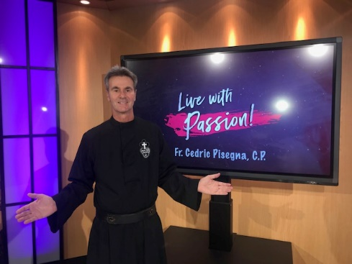
October 13, 2019
Greetings. Great news! I am emailing you to inform you I will be on Daystar’s Marcus and Joni show “Live” on Tuesday Oct. 15th. Noon ET, rebroadcast at 9 pm and 1 am ET. I hope you will tune in. I will be interviewed and I believe they will let me preach for 10 minutes or so also. I will be meeting with them in their world headquarters in Dallas Texas. This is a wonderful opportunity for my ministry and I hope you will prayerfully support me and invite others to tune in!
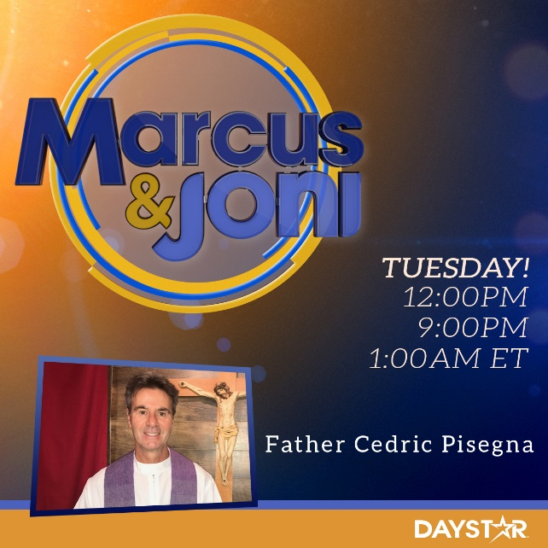
Remember also: My program Live with Passion! airs on Daystar each Sunday at 1 pm ET/ 10 am PT. Also, TBN Sundays at 7 am ET. My new series: What really Matters is now airing.
Daystar TV: Dish: 263, Direct 369, ATT 563, Fios 293, Cable: Check local listings.
Enter your zip code to find the Daystar Channel in your area: https://www.daystar.com/watch/
Download Daystar App to your phone and watch live: https://www.daystar.com/watch/apps/

Sincerely in Jesus,
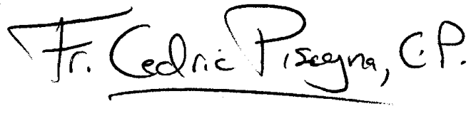
Fr. Cedric Pisegna, C.P.

